SIMATS ENGINEERING
SAVEETHA INSTITUTE OF MEDICAL AND TECHNICAL SCIENCES

Department | AIML
Course Code / Course Name | DSA0601 / Data Handling and Visualization
Experiment | Data Visualization using R
Name | A Shiva Shankar Reddy
Register Number | 192425174
Date | 29 September 2026
Day | Tuesday

SET 2
PROGRAM 1: Histogram for Customer Age Distribution
R Programming
Aim
To create a histogram using R to represent the distribution of customer ages with proper title and axis labels.
Dataset: Customer Satisfaction
Customer ID | Age | Satisfaction Score
1 | 25 | 4
2 | 30 | 5
3 | 35 | 3
4 | 28 | 4
5 | 40 | 5
Algorithm
- Start the program.
- Create a dataset containing customer ages.
- Store the age values in a variable.
- Use the hist() function to create a histogram.
- Add title and axis labels.
- Set the histogram color.
- Display the histogram.
R Program
age <- c(25, 30, 35, 28, 40)
hist(age,
col = "skyblue",
main = "Customer Age Distribution",
xlab = "Customer Age",
ylab = "Frequency",
border = "black")
grid()
Sample Input
Customer Ages:
25, 30, 35, 28, 40
Sample Output
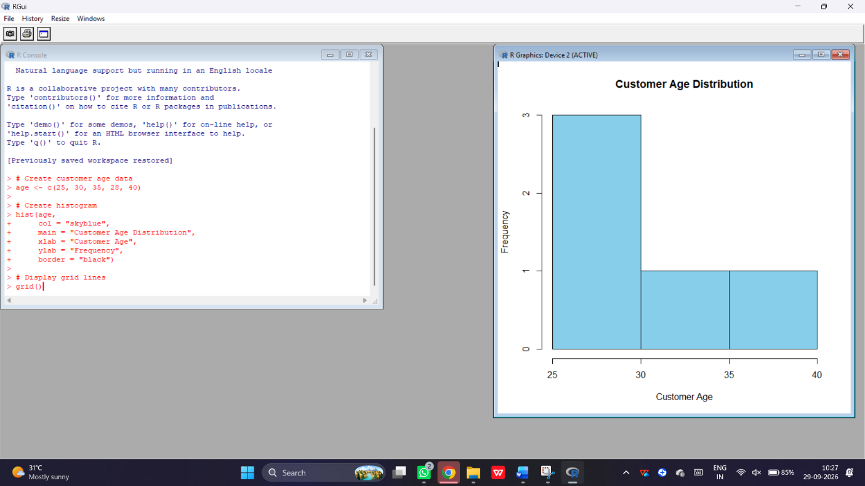
Expected observation:
- Minimum age = 25 years.
- Maximum age = 40 years.
- The histogram displays the frequency distribution of customer ages.
Result: Thus, the histogram representing the distribution of customer ages was successfully created using R.

Experiment 2: Pie Chart for Customer Satisfaction
Aim
To generate a pie chart using R to display the overall distribution of customer satisfaction scores with labels.
PROGRAM:
score <- c(4, 5, 3, 4, 5)
count <- table(score)
labels <- paste("Score", names(count))
pie(count,
labels = labels,
col = c("skyblue", "orange", "lightgreen"),
main = "Customer Satisfaction Distribution")
OUTPUT:
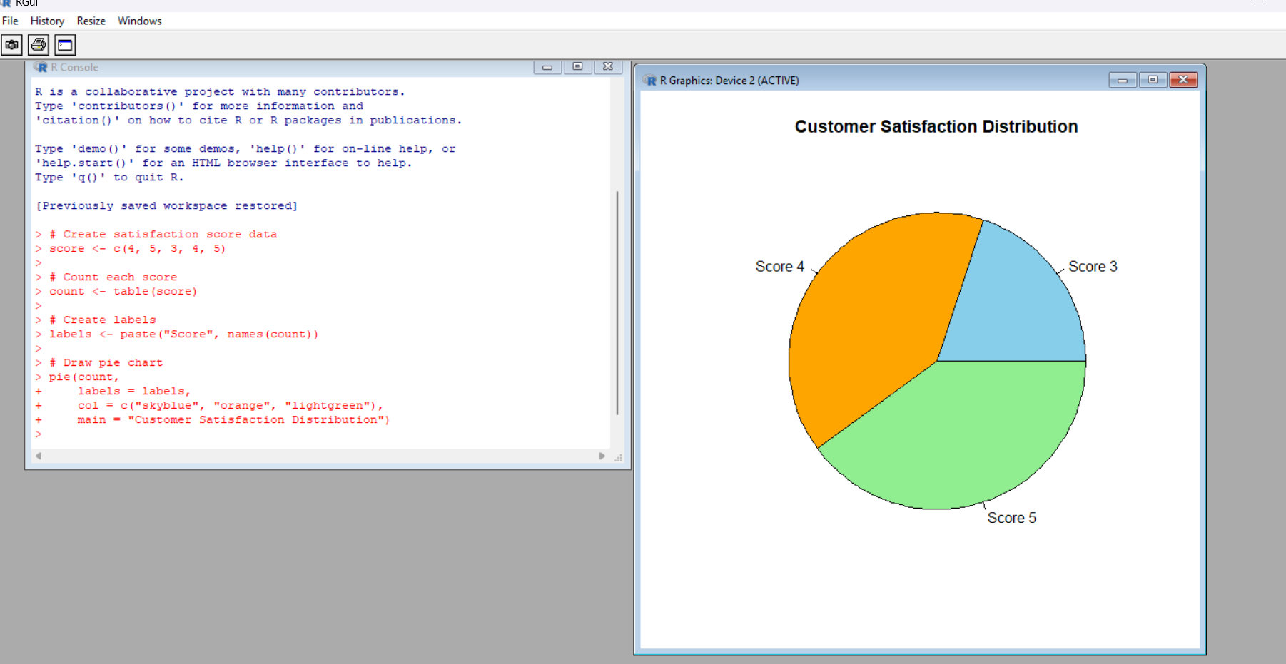
Expected frequency:
Satisfaction Score | Frequency
3 | 1
4 | 2
5 | 2
Result
Thus, the pie chart representing the distribution of customer satisfaction scores was successfully created using R.
Experiment 3: Stacked Bar Chart by Age Group
Aim
To create a stacked bar chart using R to visualize the distribution of customer satisfaction scores across different age groups.
PROGRAM:
age <- c(25, 30, 35, 28, 40)
score <- c(4, 5, 3, 4, 5)
age_group <- cut(age,
breaks = c(20, 29, 39, 49),
labels = c("20-29", "30-39", "40-49"))
data <- table(age_group, score)
barplot(t(data),
col = c("skyblue", "orange", "lightgreen"),
main = "Satisfaction by Age Group",
xlab = "Age Group",
ylab = "Number of Customers",
legend.text = rownames(t(data)))
grid()

OUTPUT
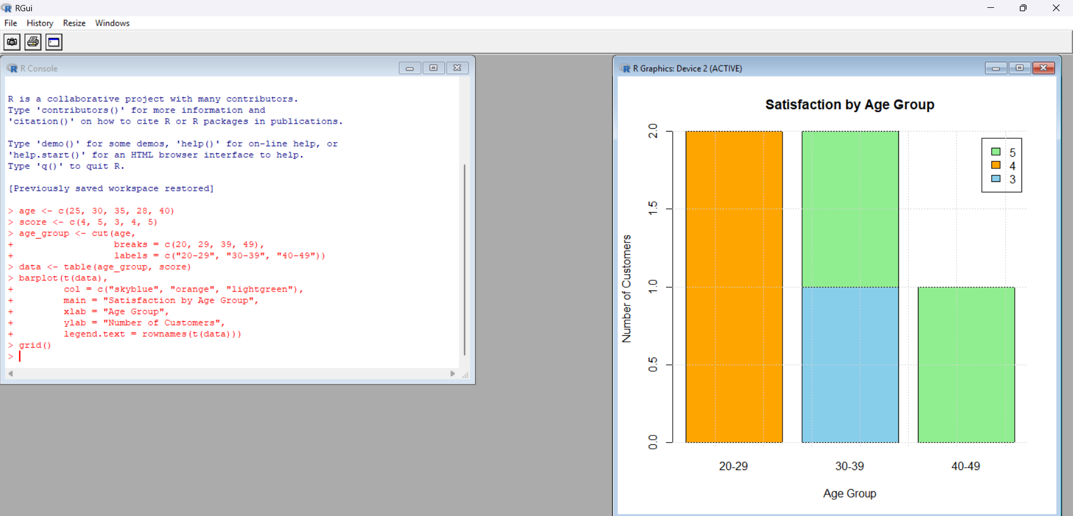
Expected observation:
- Age group 20–29 contains two customers.
- Age group 30–39 contains two customers.
- Age group 40–49 contains one customer.
- The chart displays satisfaction score distribution within each age group.
Result
Thus, the stacked bar chart showing customer satisfaction by age group was successfully created using R.
Experiment 4: Word Cloud for Customer Feedback
Aim
To develop a word cloud using R from customer feedback to identify frequently occurring words and sentiments.
PROGRAM:
library(wordcloud)
feedback <- c("Good service and good quality",
"Excellent service",
"Good product and fast delivery",
"Excellent quality",
"Fast service and friendly staff")

feedback <- tolower(feedback)
words <- unlist(strsplit(feedback, " "))
word_count <- table(words)
wordcloud(names(word_count),
freq = as.numeric(word_count),
colors = c("blue", "red", "green", "orange"),
min.freq = 1,
random.order = FALSE,
scale = c(3, 0.5),
main = "Customer Feedback Word Cloud")

OUTPUT:
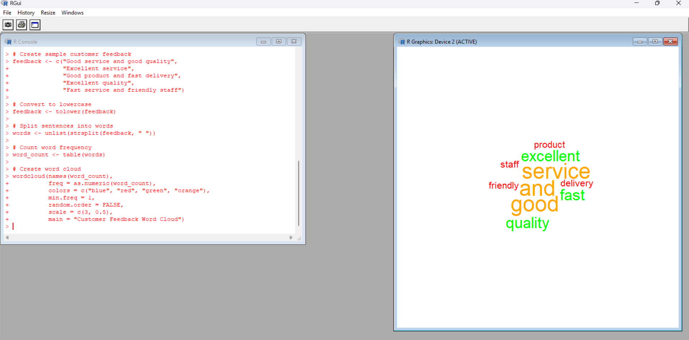
Expected observation:
- Good appears frequently.
- Service appears frequently.
- Quality and Excellent also occur multiple times.
- Frequently used words appear larger in the word cloud.
Result
Thus, a word cloud was generated using R to identify commonly occurring words in customer feedback.

